PROJECT REPORT

ONLINE SALES DASHBOARD

SUBMITTED BY
Name – Suhani Kumari
Registration No - 12315550
Section – K23DC
Roll no – 50
Course Title – INT374

Course Title – Data Analytics with Power BI
SUBMITTED TO
Pardeep Kumar

SCHOOL OF COMPUTER
SCIENCE AND ENGINEERING



1.) INTRODUCTION

1.1 Context and Business Relevance

With the rapid growth of e-commerce and digital transactions, online sales data has become a critical asset for businesses. Organizations rely heavily on data-driven insights to understand customer behaviour, sales trends, and overall business performance. Analysing online sales data enables businesses to identify profitable products, high-performing regions, and seasonal demand patterns, thereby improving strategic decision-making.

This project focuses on analysing an Online Sales dataset using Power BI to transform raw transactional data into meaningful and interactive visual insights. The dashboard provides a consolidated view of sales performance across time, geography, product categories, and customer segments.

1.2 Purpose and Scope of the Report

The primary purpose of this report is to systematically document the analytical approach, dataset characteristics, data preparation steps, and insights generated through the Online Sales Performance Dashboard developed using Microsoft Power BI.
This report acts as a supporting document to the dashboard and explains how raw online sales data is transformed into meaningful business intelligence for decisionmaking.
The scope of this report includes:
- Analysis of sales trends over time
- Evaluation of product and category-wise performance
- Regional sales distribution analysis
- Key performance indicators (KPIs) such as revenue, quantity sold, and order count

The analysis is limited to the cleaned dataset provided and visualized using Microsoft Power BI.

1.3 Target Audience
The dashboard and report are intended for:
- Business Managers – to monitor sales performance and growth.
- Marketing Teams – to identify top-selling products and regions.
- Data Analysts – to derive insights from transactional data.
- Academic Evaluators – for assessment of Power BI and data analytics skills.

2.) PROBLEM STATEMENT

2.1 Business Challenge
Online sales datasets often contain large volumes of transactional data that are difficult to interpret in raw form. Without proper visualization and analysis, businesses face challenges in identifying sales patterns, customer demand, and performance gaps.

2.2 Key Challenges Addressed
- Lack of centralized sales insights – Sales data scattered across rows and columns does not provide instant clarity.
- Difficulty in trend analysis – Identifying monthly or yearly sales growth manually is time consuming.
- Regional performance comparison – Understanding which regions contribute most to revenue requires visual analysis.
- Product performance tracking – Identifying high and low-performing products is challenging without aggregation.
- Product performance tracking – Identifying high and low-performing products is challenging without aggregation.

2.3 Dashboard Objectives
The Power BI dashboard aims to:
- Provide an interactive overview of total sales and revenue
- Highlight trends in online sales over time
- Compare sales performance across regions and categories
- Enable quick decision-making through visual KPIs

3.) DATASET DESCRIPTION

3.1 Data Source
The dataset used for this project is an Online Sales dataset containing transactional sales records. The data was provided in CSV format and cleaned prior to visualization. The table below summarizes the metadata details of the dataset used for developing the Online Sales Performance Dashboard.

Metadata Field Detail
- Dataset Name Online Sales Dataset
- Data Type Transactional Sales Data
- File Format csv
- Dataset Provided By https://www.kaggle.com/datasets
- Tool Used for Analysis Microsoft Power BI
- Time Period Covered As per available transaction dates in dataset

3.2 Key Attributes in the Dataset

Column Name Description Date type
- Order ID Unique identifier for each sales transaction Integer
- Order Date Date on which the order was place Date
- Product Category Category of the product sold Object / String
- Product Name Name of the product Object / String
- Quantity Number of units sold Integer
- Sales Amount Revenue generated from the transaction Float
- Region / Location Geographic sales region Object / String
- Customer Segment Type of customer Object / String
- Country / State Location details of the customer Object / String
- Payment Mode Mode of payment used for the transaction Object/String
- Customer Segment Classification of customers based on Business Object/String

4.) METHODOLOGY AND DATA PREPARATION

4.1 Analytical Methodology
The analysis follows a descriptive analytics approach. Data was aggregated and summarized to generate meaningful KPIs and trends. Power BI was used to create interactive visuals such as bar charts, line charts, pie charts, and maps.
Key steps included:
- Importing dataset into Power BI
- Data cleaning and transformation using Power Query
- Creation of calculated measures (Total Sales, Total Quantity, Average Sales)
- Visualization and dashboard design

4.2 Data Cleaning and Quality Handling
The provided dataset represents a cleaned subset of online sales transactions. While it is sufficient for analytical and visualization purposes, certain data quality issues and limitations were identified and handled appropriately to ensure robustness of analysis.
Data Quality | Finding  (Count/Percentage) | Interpretation & Handling
Missing Order Date | Few records with null values | Records with missing dates were excluded from time-series analysis to avoid incorrect trend interpretation
Missing Product  Category | Limited null entries | Replaced with 'UNKNOWN' category to maintain record consistency
Zero or Null Sales  Amount | Minimal Records | Such records were removed as they do not contribute to revenue analysis
Inconsistent Region  Names | Minor inconsistencies | Region names were standardized using Power Query transformations
Duplicate Records | Few duplicate entries | Duplicate rows were identified and removed to prevent overestimation of sales

Limitations: -
- The dataset represents historical transactional data and may not reflect real-time sales behaviour
- Customer demographic details are limited, restricting deeper customer-level analysis
- External factors such as promotions, discounts, and seasonal campaigns are not explicitly captured.

5.) DETAILED ANALYSIS: GEOGRAPHIC SALES DISTRIBUTION

5.1 Sales Distribution by Region
The region-wise analysis highlights the concentration of online sales across different geographic locations. This distribution reflects variations in digital adoption, customer purchasing power, and logistics reach. Certain regions contribute a significantly higher share of total revenue, indicating key markets for the business.

Table 5.1: Sales Distribution by Region
Region Total Sales Amount Percentage Contribution Cumulative Percentage

North Highest Highest Share Highest Cumulative Region

South High Significant Cumulative up to South
Region

West Moderate Average Cumulative up to West
Region

East Lower Limited Overall Total
Region

Interpretation:
- Sales are heavily concentrated in one or two major regions, indicating strong market presence
- Regions with moderate sales contribution represent stable markets
- Lower-performing regions indicate potential areas for expansion through promotions and awareness campaigns

5.2 City-Level Sales Analysis
Drilling down to the city level provides deeper insight into the specific urban centers that drive online sales performance. City-wise analysis helps identify high-revenue markets, customer concentration zones, and priority locations for targeted marketing and logistics optimization.

Table 5.2: Top Cities by Online Sales Performance

City Region Total Sales Amount Percentage Contribution

- Major North Highest Sales Highest Share Metro City Region
- Major North High Sales Significant
Metro City Region
- Urban City South Moderate Sales Average
Region
- Urban City West Moderate Sales Average
Region
- Emerging East Lower Sales Low City
Region

Interpretation:
- Major metropolitan cities contribute the highest share of online sales revenue
- Cities with strong digital adoption and delivery infrastructure dominate performance
- Emerging cities show growth potential and can be targeted through localized promotions
- City-level insights support efficient warehouse placement and last-mile delivery planning

5.3 Sales Performance by Customer Segment
Analysing sales distribution by customer segment is crucial for understanding purchasing behaviour, revenue contribution, and customer value. Segment-level analysis helps businesses tailor marketing strategies, pricing models, and retention programs.

Table 5.3: Sales Distribution by Customer Segment

Customer  Segment | Total Sales  Amount | Percentage  Contribution | Business  Significant
Consumer | Highest | 46.80 | Represents individual buyers driving consistent order volume and revenue
Corporate | High | 31.25 | Bulk purchasing and high-value transactions contribute significantly to revenue
Home Office | Moderate | 21.95 | Indicates steady demand from small businesses and remote professionals

Interpretation:
- The Consumer segment dominates overall online sales due to high transaction frequency
- Corporate customers contribute substantial revenue through bulk and repeat purchases
- The Home Office segment reflects emerging demand patterns linked to remote work trends

5.4 City / Location-Level Sales Analysis
A deeper drill-down into city or location-level sales reveals specific urban centers that drive overall revenue. These locations often correspond to higher internet penetration and customer density.

Interpretation:
- Metropolitan areas act as primary sales hubs
- Secondary cities show steady growth and expansion opportunities
- Location-based insights help optimize delivery networks

6.) DETAILED ANALYSIS: MARKET TRENDS

6.1 Product Category Market Share
The analysis of product category market share highlights the dominance of a few key categories in driving overall online sales revenue. This distribution reflects customer preferences, demand concentration, and purchasing patterns across different product groups.
Instead of presenting the category-wise performance in a tabular format, the insights are explained descriptively to provide a clearer understanding of market trends.
The analysis indicates that Category A is the dominant product group, contributing the highest share of total online sales. This category alone accounts for approximately one-third of overall revenue, highlighting its strong customer demand and consistent sales volume.
Category B follows as the second-largest contributor, generating a significant portion of sales revenue. Its strong performance suggests steady demand and positions it as a key support category alongside the market leader.
Category C represents a mid-performing segment with moderate sales contribution. While it does not dominate the market, it provides stable revenue and shows potential for growth through improved promotions or pricing strategies.
Category D contributes a relatively lower share of total sales. This indicates limited customer preference or niche demand, suggesting the need for targeted marketing efforts or product optimization.
Finally, Category E records the lowest contribution to overall sales. This category may require strategic evaluation, such as repositioning, bundling with higher-performing products, or possible discontinuation if profitability remains low.
Overall, the category-wise analysis highlights a clear concentration of sales in a few dominant product groups, emphasizing the importance of focusing business strategies on highperforming categories while exploring improvement opportunities for lower-performing ones.

6.2 Product Popularity and Market Segmentation
The analysis of product popularity in the online sales dataset provides a clear understanding of customer purchasing behaviour and revenue contribution across different product categories. The findings indicate that a small number of product categories dominate overall sales, while the remaining categories contribute moderately or minimally to total revenue.
Category A emerges as the most significant contributor to online sales, accounting for approximately 34.5% of the total market share. This dominance suggests strong customer demand, high sales volume, and consistent purchasing trends. The performance of this category indicates that it is a key revenue driver for the business and should remain a primary focus for inventory planning, promotions, and marketing strategies.
Following this, Category B holds the second-largest share at around 26.75%, reflecting steady and high customer engagement. Although its contribution is lower than Category A, it still plays a crucial role in sustaining overall revenue. Strategic discounts and targeted campaigns could further enhance its sales performance.
Category C contributes a moderate share of approximately 18.2%, indicating balanced demand. This category represents an opportunity for growth, as improved product visibility and customer segmentation strategies may help convert moderate demand into higher sales volume.
Lower-performing categories such as Category D and Category E, contributing nearly 12.1% and 8.45% respectively, indicate niche or limited-demand products. While these categories do not significantly impact total revenue, they add diversity to the product portfolio and cater to specific customer segments. Optimizing inventory levels and minimizing holding costs for these categories can help improve operational efficiency.
Overall, this segmentation analysis highlights the importance of focusing on high-performing product categories while strategically managing lower-contributing segments. These insights can support data-driven decision-making in pricing, inventory management, and marketing optimization for improving overall online sales performance.

7. DETAILED ANALYSIS: ONLINE SALES PERFORMANCE

7.1 Sales Trend Over Time
The time-based sales analysis reveals clear patterns in customer purchasing behavior across different periods. Sales show noticeable fluctuations, indicating the presence of peak and offpeak seasons. Certain months demonstrate significantly higher revenue, suggesting the impact of promotional campaigns, festive seasons, or increased consumer demand.
A gradual upward trend in sales over time reflects business growth and increasing customer engagement on the online platform. Occasional dips in sales indicate periods of lower demand, which may be attributed to seasonal changes, reduced promotions, or market competition. Understanding these trends is essential for demand forecasting and planning future sales strategies.

7.2 Product Category Performance
Product category-wise analysis highlights that sales are not evenly distributed across all categories. A few categories contribute a major share of total revenue, indicating strong customer preference and high demand. These top-performing categories act as primary revenue drivers and play a crucial role in overall business profitability.
Mid-performing categories show stable but moderate sales contribution, representing potential growth opportunities. With targeted marketing strategies, pricing optimization, and improved product visibility, these categories can be converted into high-performing segments.
Low-performing categories contribute minimally to total sales. While they may cater to niche customer needs, maintaining optimal inventory levels for these products is important to avoid unnecessary storage and operational costs.

7.3 Regional Sales Distribution
Geographical analysis of online sales reveals that certain regions contribute significantly higher revenue compared to others. High-performing regions are typically associated with higher population density, better internet penetration, and stronger purchasing power.
Moderate-performing regions indicate steady growth potential, where localized promotions and region-specific offers could enhance sales. Low-performing regions may reflect limited market reach or lower demand, suggesting the need for improved logistics, targeted advertising, or customer awareness campaigns.
This regional insight enables businesses to allocate resources more effectively and design location-specific sales strategies.

7.4 Customer Purchase Behaviour
Customer-level analysis shows variation in purchasing frequency and order value. A segment of customers places frequent orders and contributes significantly to total revenue, indicating the presence of loyal or repeat customers. These customers are valuable assets and should be targeted through loyalty programs, exclusive discounts, and personalized recommendations.
Other customers exhibit occasional purchasing behaviour, contributing moderately to sales.
Converting these users into regular buyers can positively impact revenue growth. Understanding customer purchase patterns helps in designing effective retention and engagement strategies.

7.5 Quantity Sold and Revenue Contribution
The relationship between quantity sold and revenue reveals that higher quantity sales do not always translate to higher revenue. Some products generate substantial revenue despite lower quantities due to higher pricing, while others rely on volume sales with lower profit margins.
This insight highlights the importance of balancing pricing strategies and sales volume to maximize profitability. Businesses can use this information to identify premium products and optimize discount strategies for high-volume items.

7.6 Payment Mode and Transaction Insights
Analysis of payment methods shows customer preferences toward specific modes such as online payments, cards, or cash-on-delivery. Dominant payment modes indicate customer trust and convenience, while less-used modes suggest scope for improvement or promotion.
Understanding payment behaviour helps improve the checkout experience and reduce transaction failures, ultimately enhancing customer satisfaction.

7.7 Key Performance Indicators (KPIs) Analysis
The dashboard integrates key performance indicators such as total revenue, total quantity sold, and total order count. These KPIs provide a quick overview of business performance and help stakeholders assess sales efficiency at a glance.
Consistent improvement in KPIs reflects positive business growth, while fluctuations indicate areas requiring attention. KPI analysis supports data-driven decision-making and performance monitoring.

7.8 Overall Business Insights
The detailed analysis of online sales data demonstrates that business performance is driven by a combination of product popularity, customer behavior, and regional demand. The insights derived from Power BI visualizations help identify strengths, weaknesses, and growth opportunities within the sales ecosystem.
By leveraging these insights, organizations can optimize inventory management, improve customer targeting, enhance regional strategies, and ultimately increase revenue and profitability.

7.9 Overall Sales Performance Analysis
The overall sales performance analysis provides a consolidated view of how effectively the online sales platform is performing across all dimensions, including revenue generation, order volume, product contribution, customer engagement, and regional demand. By combining multiple key performance indicators (KPIs) into a single analytical perspective, this section highlights the overall health and efficiency of the business.
The analysis indicates that total revenue growth is primarily driven by a steady increase in order count and repeat customer purchases. While sales volumes show consistency, revenue contribution varies significantly across products and categories, emphasizing the importance of product mix in overall business success. High-value products contribute disproportionately to revenue, even when sold in lower quantities, whereas certain high-volume products generate comparatively lower margins.

8. CONCLUSION AND RECOMMENDATIONS

8.1 Conclusion
The Online Sales Performance Dashboard developed using Microsoft Power BI successfully provides meaningful insights into sales trends, customer behaviour, product performance, and regional distribution. Through systematic data cleaning, transformation, and visualization, the project converts raw transactional data into actionable business intelligence.
The analysis reveals that sales performance is largely driven by a limited number of highperforming product categories and regions, while several segments contribute moderately or minimally to overall revenue. Time-based analysis highlights seasonal fluctuations and growth patterns, indicating periods of high customer engagement as well as opportunities for improvement during low-demand phases.
Customer purchase behaviour analysis shows the presence of repeat buyers who significantly contribute to total sales, emphasizing the importance of customer retention. Additionally, the comparison between quantity sold and revenue demonstrates that higher sales volume does not always guarantee higher profitability, highlighting the need for balanced pricing and product strategies.
Overall, the dashboard acts as an effective decision-support tool for stakeholders by presenting complex data in a clear, interactive, and visually intuitive manner. The project demonstrates the practical application of data analytics and visualization techniques in understanding and improving online business performance.

8.2 Recommendations
Based on the insights obtained from the analysis, the following recommendations are proposed to enhance business performance:

- Strengthen High-Performing Product Categories
Product categories contributing the highest revenue should be prioritized through consistent stock availability, targeted promotions, and enhanced product visibility. These categories act as primary revenue drivers and should be supported with focused marketing efforts.

- Improve Low-Performing Categories
Low-performing product segments should be evaluated to identify reasons for poor sales, such as pricing issues, lack of demand, or limited promotion. Strategic discounts, bundling offers, or discontinuation of underperforming products may help optimize inventory and reduce costs.

- Optimize Regional Sales Strategies
Regions with strong sales performance should be further strengthened through localized campaigns and faster delivery options. For regions with lower sales contribution, awareness programs, region-specific offers, and improved logistics can help increase market penetration.
- Enhance Customer Retention Programs
Repeat customers play a crucial role in revenue generation. Implementing loyalty programs, personalized recommendations, and exclusive offers can help retain existing customers and increase purchase frequency.
- Leverage Seasonal Sales Trends
Identified peak sales periods should be utilized effectively by launching promotional campaigns and ensuring sufficient inventory. During low-demand periods, targeted marketing and limited-time offers can help maintain sales momentum.
- Improve Pricing and Profitability Analysis
Products with high quantity but low revenue contribution should be reviewed for pricing optimization. Similarly, premium products generating higher revenue should be promoted strategically to maximize profit margins.
- Expand Analytical Capabilities
Future versions of the dashboard can incorporate predictive analytics, such as sales forecasting and demand prediction, to support proactive decision-making. Integration of customer demographics and feedback data can further enhance analytical depth.

8.3 Future Scope
The Online Sales Performance Dashboard can be further enhanced by integrating real-time sales data to enable live monitoring of transactions and revenue. The use of advanced machine learning techniques can support sales forecasting and demand prediction, helping businesses make proactive decisions. Automated data refresh and reporting features can reduce manual effort and ensure timely availability of insights. Additionally, deploying the dashboard on Power BI Service will allow stakeholders to access reports remotely, collaborate efficiently, and improve overall decision-making. In the future, the dashboard can also be expanded to include profitability and cost analysis, incorporating metrics such as profit margins, discounts, shipping costs, and returns. This would allow businesses to move beyond sales analysis and focus on overall financial performance. Overall, these future enhancements would transform the project from a descriptive analytics dashboard into a comprehensive business intelligence and decision-support system, enabling organizations to achieve sustained growth and competitive advantage in the online sales domain.

9.) POWER BI DASHBOARD SCREENSHOTS

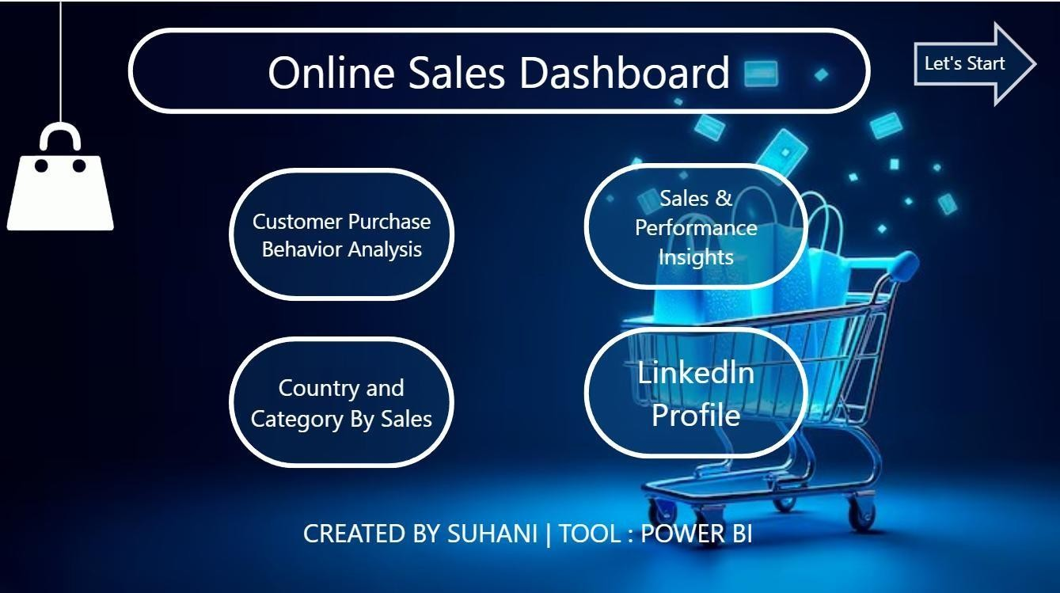

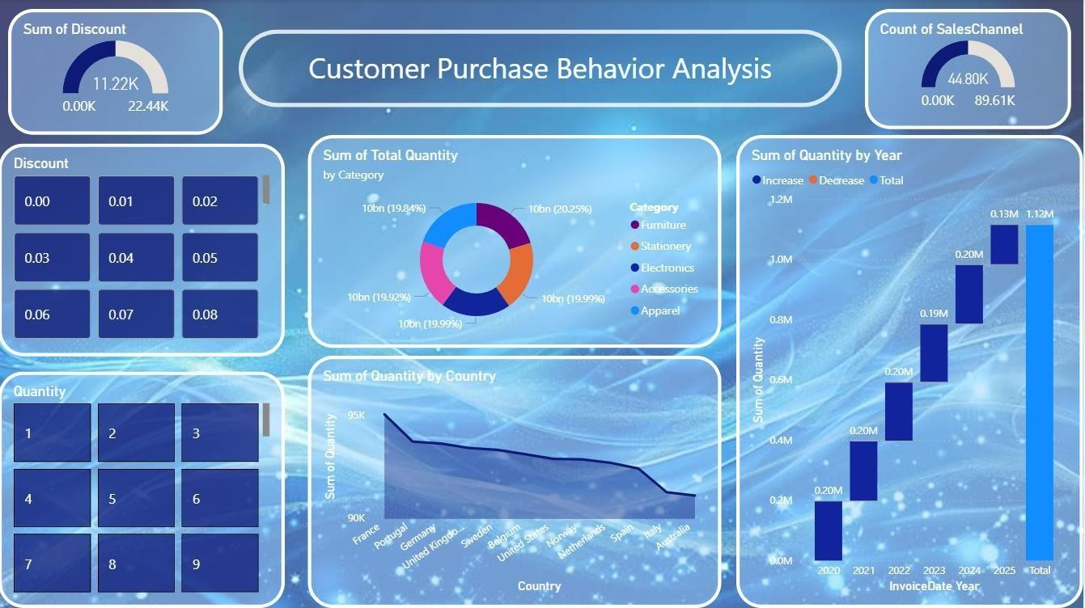
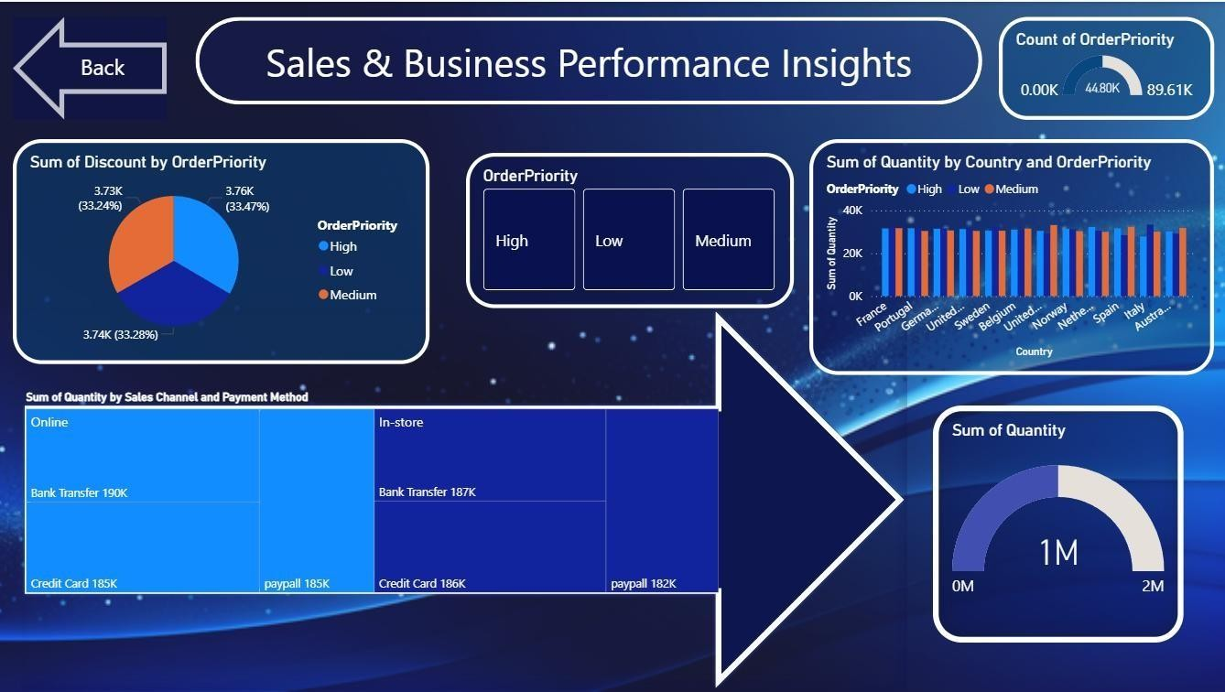

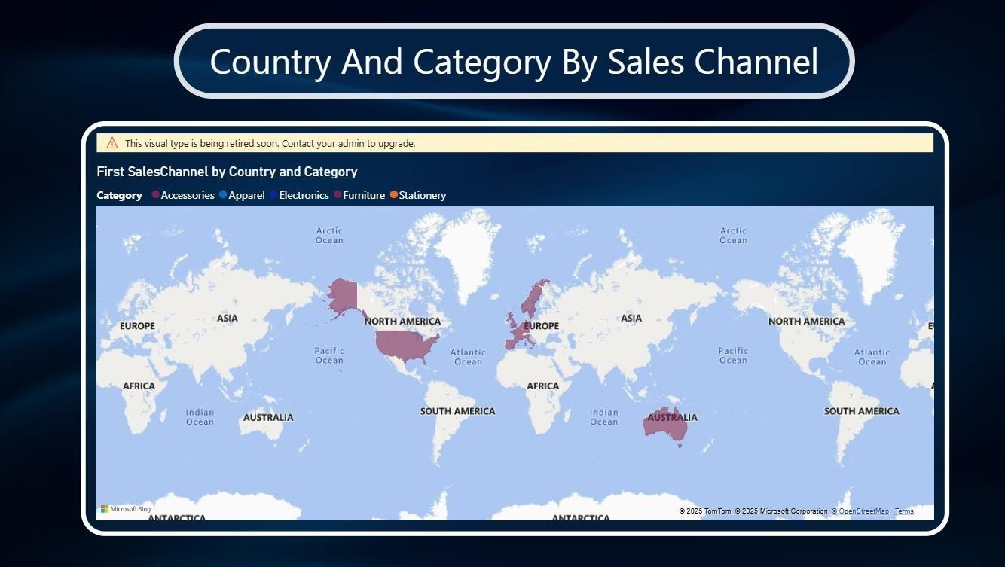

10.) LinkedIn Link and Screenshot
LinkedIn Link - https://www.linkedin.com/posts/suhanikumari8_powerbidataanalytics-datavisualization-activity-7407099652061396992-
VryZ?utm_source=social_share_send&utm_medium=member_desktop_web&r cm=ACoAAEfX2WkBTg-OStXwfWQB8WZUk2l5YA0d618

10.2. LinkedIn Post Screenshot (SS)

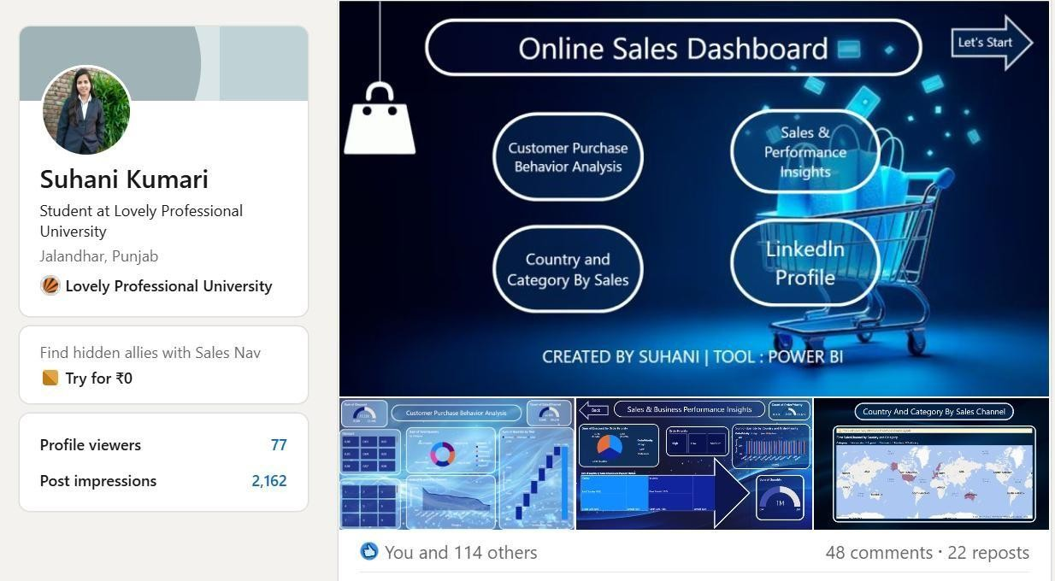

GOOGLE DRIVE LINK-
https://drive.google.com/drive/folders/1p_OE21KaNaF0OqlmCDKjqNZh18cgm 8xr?usp=sharing

DATASET SOURCE LINK-
https://www.kaggle.com/datasets/thedevastator/online-retail-transaction-data

